**This is the technical test for developers:**

**You will have 90 minutes to complete the following exercise.**

**85 MINUTES** to create and send **3 files** (HTML, CSS and JavaScript) of a progress bar that shows a process completion using 2 number inputs (quantity or progress and the goal), it will display the progress of x% out of a total of 100%. Here’s an example of how it could look, but the design must be like the midware website (midware.net), add the option to hide/show the progress bar or add other elements, if you want:

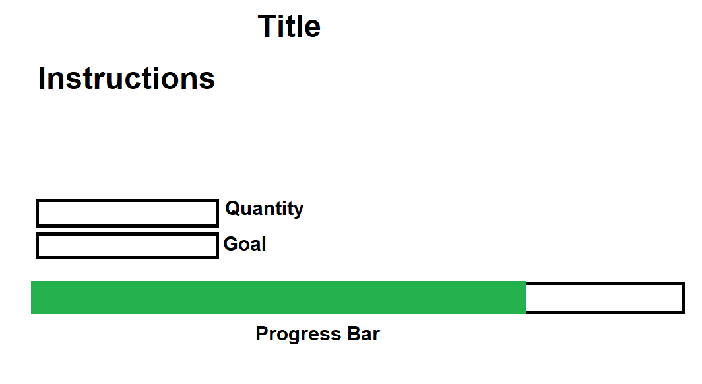

Here are a few examples:

* Quantity = 50, Goal = 200, Progress Bar = 25%
* Quantity = 90, Goal = 100, Progress Bar = 90%
* Quantity = 354, Goal = 590, Progress Bar = 60%

We will evaluate you on creativity, logic, functionality, validations and completion time. You must create it from scratch and can search on the internet. **You can’t use other libraries.**

And… You’ll also have **5 MINUTES** to write and send an email IN ENGLISH to your client explaining what you did in the provided time and how s/he could use it.

Once again, send **the email and the 3 files** to [careers@midware.net](mailto:careers@midware.net) with “MIDWARE TEST” and your name as subject line. For example: **MIDWARE TEST - JOHN DOE**